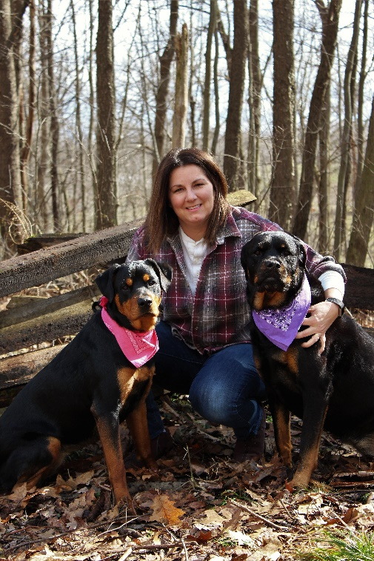**Groomer**

Taryn started with North Memorial since February 2017. She has been grooming for ten years. She lives with her husband, daughter, and son. They have two Rottweilers, “Raina” and “Kimber”. In her spare time, Taryn enjoys spending time with her family, outdoor activities, watching sporting events, and photography.